Installation Guide

1. ***Software Requirement.***

Java SE 8 or Newer

MySQL 8.0 or Newer

Eclipse latest versions.

1. ***Configuration***
2. ***Java Installation Guide***

This Java Development Kit (JDK) allows you to code and run Java programs. It's possible that you install multiple JDK versions on the same PC. But Its recommended that you install only latest version.

Following are steps to install Java in Windows

**Step 1)** Go to [link](http://www.oracle.com/technetwork/java/javase/downloads/index.html). Click on Download JDK. For java latest version.

[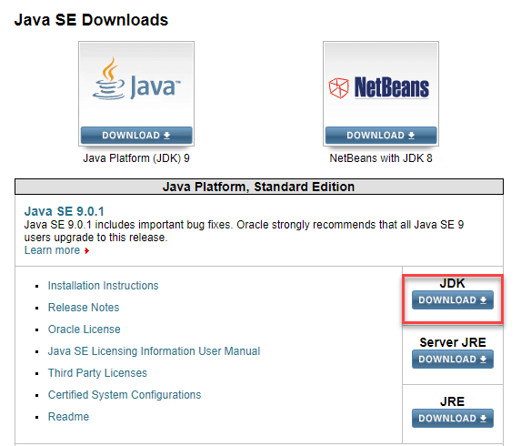](https://www.guru99.com/images/java/111417_1107_Java21.png)

**Step 2)** Next,

1. Accept License Agreement
2. Download latest Java JDK for your version(32 or 64 bit) of java for Windows.

[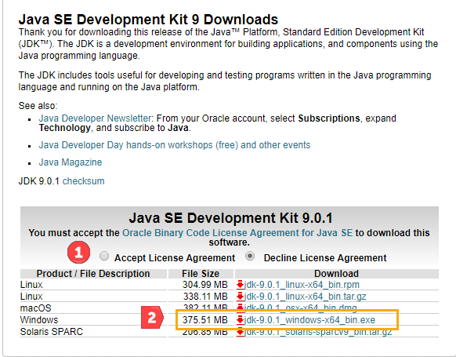](https://www.guru99.com/images/java/111417_1107_Java22.png)

**Step 3)** Once the download is complete, run the exe for install JDK. Click Next

[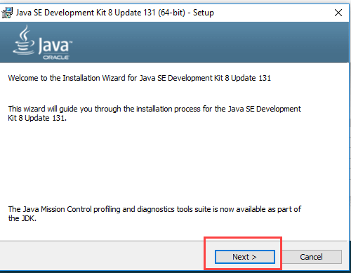](https://www.guru99.com/images/java/111417_1107_Java23.png)

**Step 4)** Once installation is complete click Close

[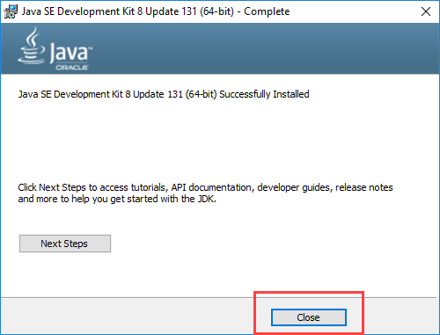](https://www.guru99.com/images/java/111417_1107_Java24.png)

**How to set Environment Variables in Java: Path and Classpath**

The PATH variable gives the location of executables like javac, java etc. It is possible to run a program without specifying the PATH but you will need to give full path of executable like ***C:\Program Files\Java\jdk1.8.0_131\bin\javac A.java*** instead of simple ***javac A.java***

The CLASSPATH variable gives location of the Library Files.

Let's look into the steps to set the PATH and CLASSPATH

**Step 1)** Right Click on the My Computer and Select the properties

[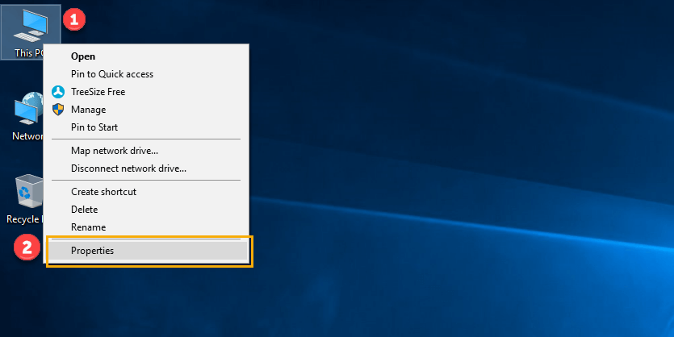](https://www.guru99.com/images/java/111417_1107_Java25.png)

**Step 2)** Click on advanced system settings

[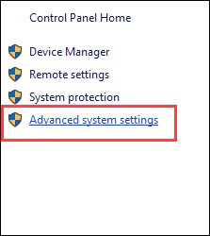](https://www.guru99.com/images/java/111417_1107_Java26.png)

**Step 3)** Click on Environment Variables

[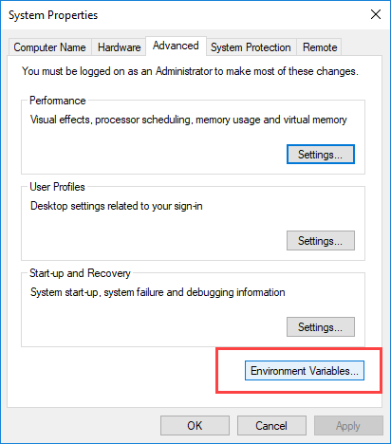](https://www.guru99.com/images/java/111417_1107_Java27.png)

**Step 4)** Click on new Button of User variables

[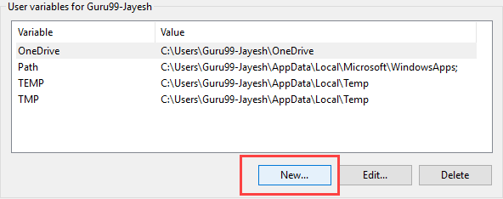](https://www.guru99.com/images/java/111417_1107_Java28.png)

**Step 5)** Type PATH in the Variable name.

[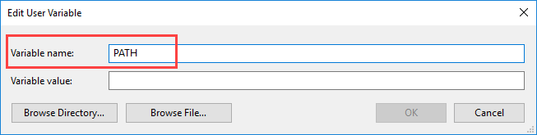](https://www.guru99.com/images/java/111417_1107_Java29.png)

**Step 6)** Copy the path of bin folder which is installed in JDK folder.

[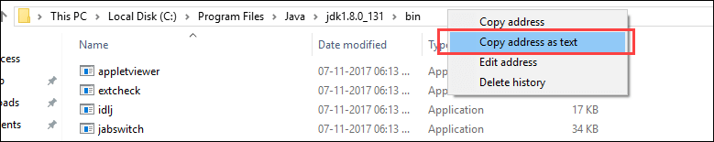](https://www.guru99.com/images/java/111417_1107_Java210.png)

**Step 7)** Paste Path of bin folder in Variable value and click on OK Button.

[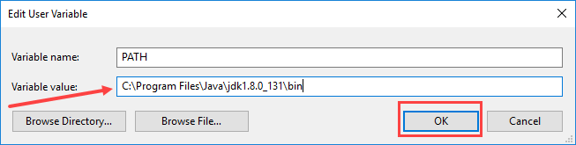](https://www.guru99.com/images/java/111417_1107_Java211.png)

**Note:** In case you already have a PATH variable created in your PC, edit the PATH variable to

PATH = <JDK installation directory>\bin;%PATH%;

Here, %PATH% appends the existing path variable to our new value

**Step 8)**You can follow a similar process to set CLASSPATH.

[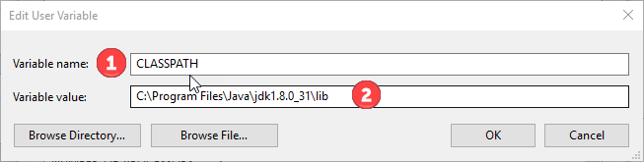](https://www.guru99.com/images/java/1.png)

**Note:** In case you java installation does not work after installation, change classpath to

CLASSPATH = <JDK installation directory>\lib\tools.jar;

**Step 9)** Click on OK button

[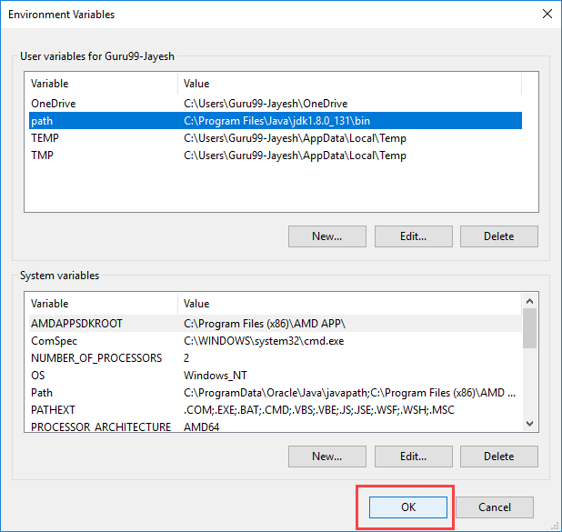](https://www.guru99.com/images/java/111417_1107_Java213.png)

**Step 10)** Go to command prompt and type javac commands.

If you see a screen like below, Java is installed.

[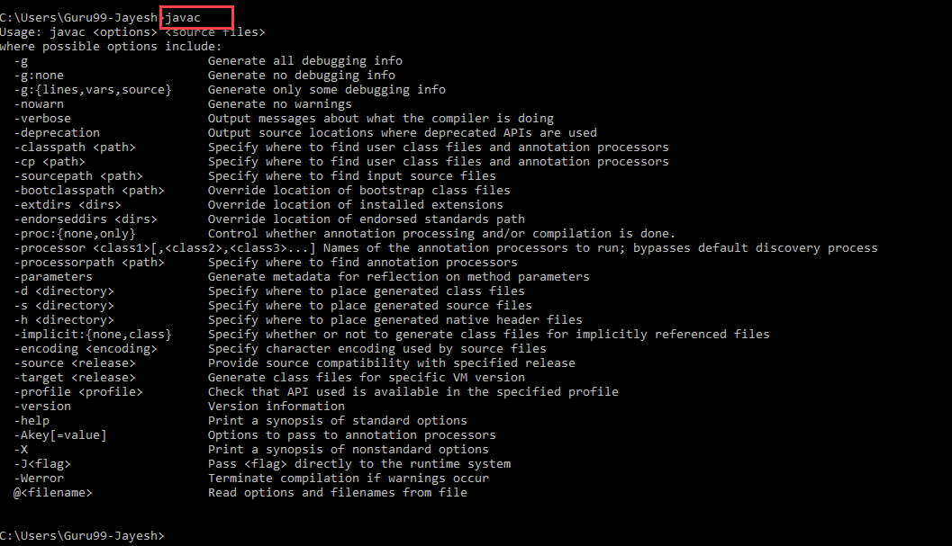](https://www.guru99.com/images/java/111417_1107_Java214.png)

1. ***MySQL Installation Guide***

f you want to install MySQL on Windows environment, using MySQL installer is the easiest way. MySQL installer provides you with an easy-to-use wizard that helps you to install MySQL with the following components:

* MySQL Server
* All Available Connectors
* MySQL Workbench with Sample Data Models
* MySQL Notifier
* Tools for Excel and Microsoft Visual Studio
* MySQL Sample Databases
* MySQL Documentation

To download MySQL installer, go to the following link <http://dev.mysql.com/downloads/installer/>. There are two files are available. If you are connecting to the internet while installing MySQL, you can choose the online installation version  mysql-installer-web-community.exe . If you want to install MySQL offline, you can download the  mysql-installer-community.exe  file.

## Install MySQL via MySQL Installer

To install MySQL using the MySQL installer, double-click on the MySQL installer file and follow the steps below:

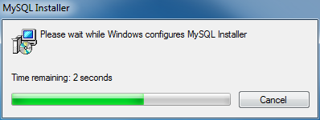  
Install MySQL Step 1: Windows configures MySQL Installer

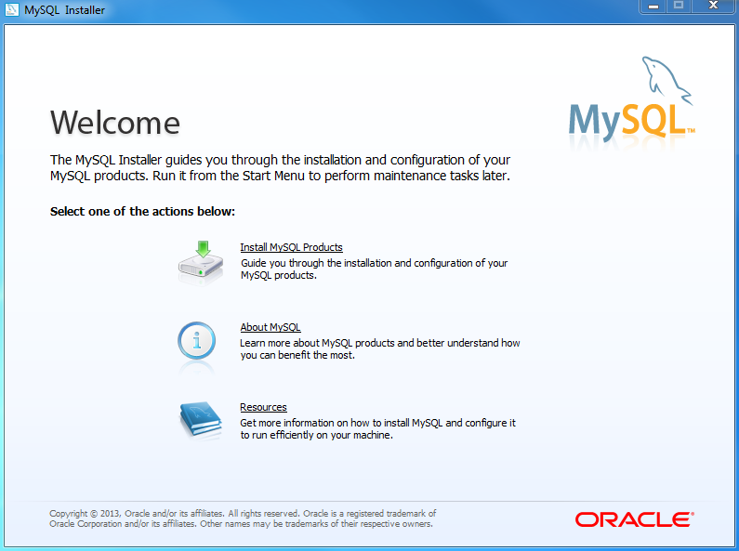  
Install MySQL Step 2 – Welcome Screen: A welcome screen provides several options. Choose the first option: Install MySQL Products

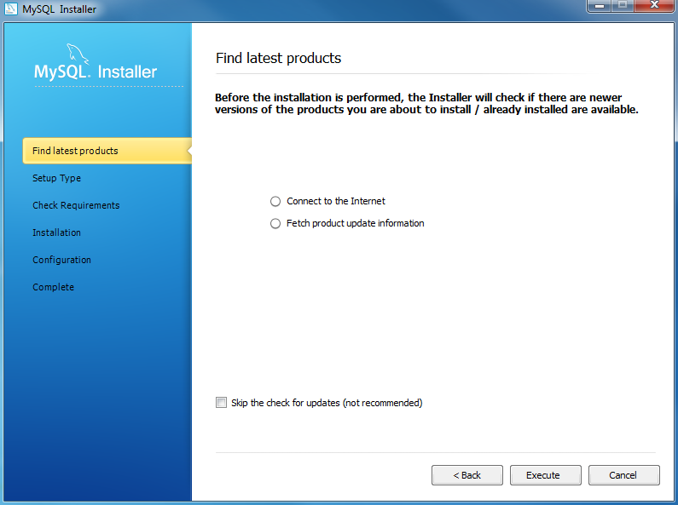  
Install MySQL Step 3 – Download the latest MySQL products: MySQL installer checks and downloads the latest MySQL products including MySQL server, MySQL Workbench, etc.

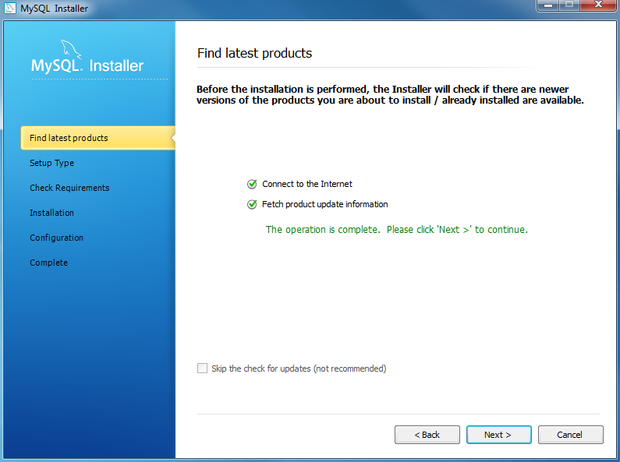  
Install MySQL Step 4: Click Next button to continue

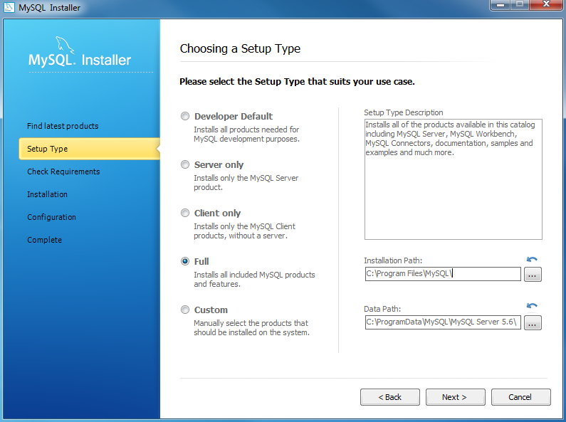  
Install MySQL Step 5 – Choosing a Setup Type: there are several setup types available. Choose the Full option to install all MySQL products and features.

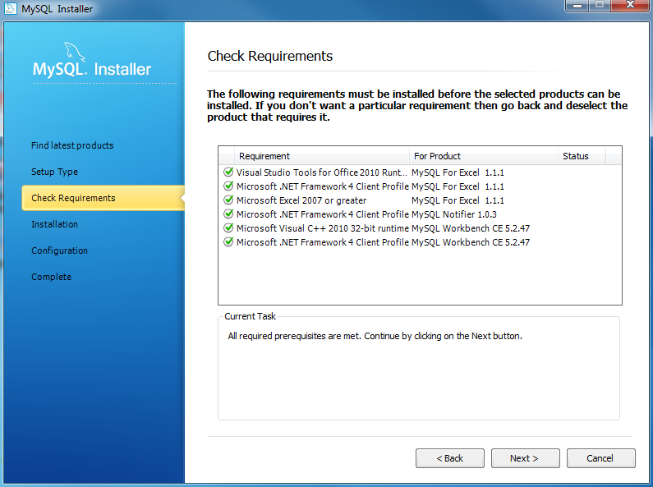  
Install MYSQL Step 6 – Checking Requirements

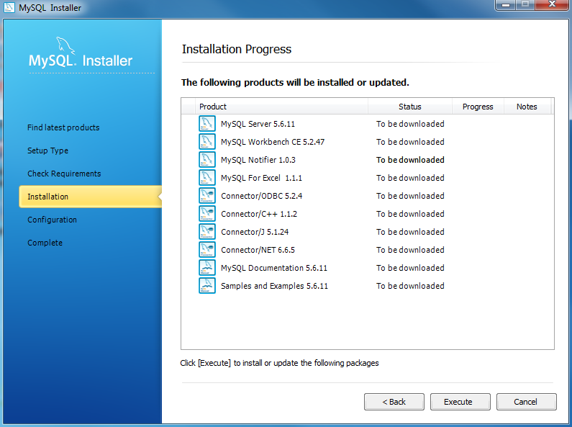  
Install MySQL Step 7 – Installation Progress: MySQL Installer downloads all selected products. It will take a while, depending on which products that you selected and the speed of your internet connection.

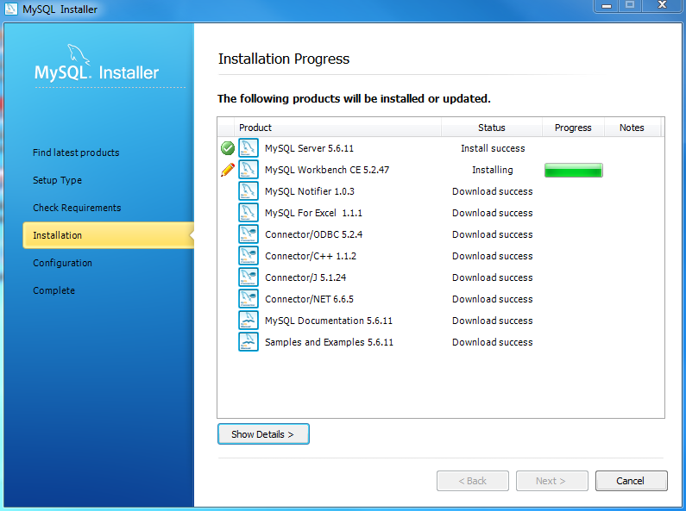  
Install MySQL Step 7 – Installation Progress: downloading Products in progress.

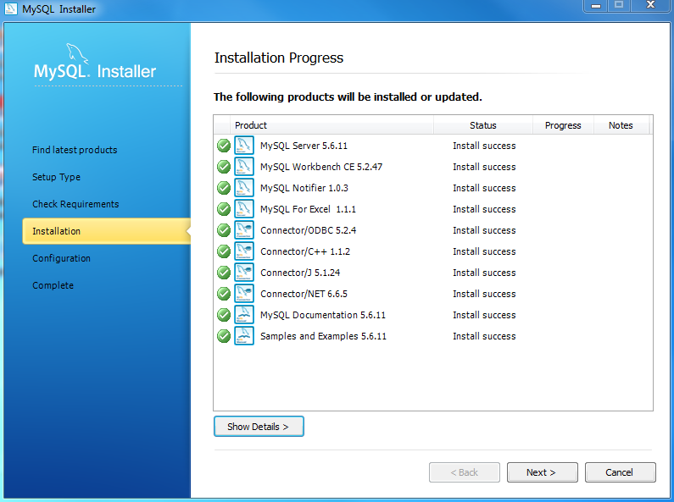  
Install MySQL Step 7 – Installation Progress: Complete Downloading. Click Next button to continue…

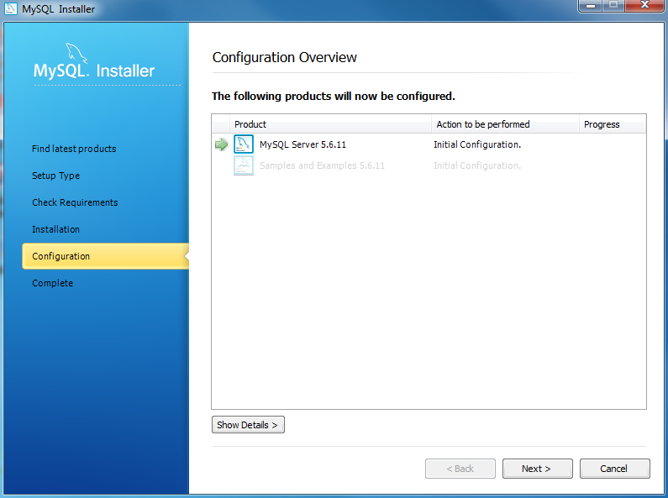  
Install MySQL Step 8 – Configuration Overview. Click Next button to configure MySQL Database Server

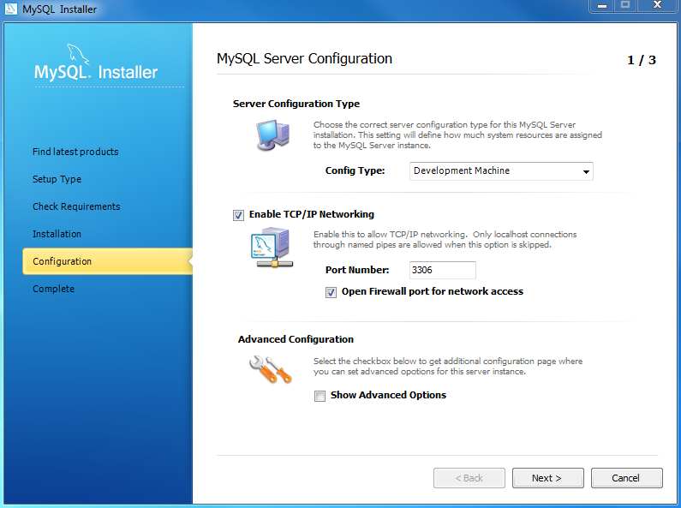  
Install MySQL Step 8.1 – MySQL Server Configuration: choose Config Type and MySQL port (3006 by default) and click Next button to continue.

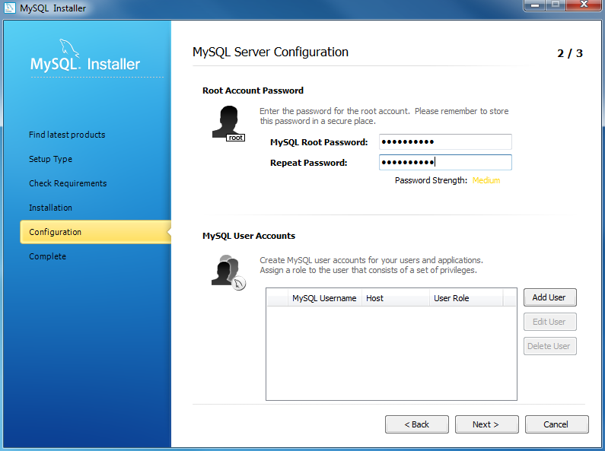  
Install MySQL Step 8.1 – MySQL Server Configuration: choose a password for the root account. Please note the password download and keep it securely if you are installing MySQL database server on a production server. If you want to add a more MySQL user, you can do it in this step.

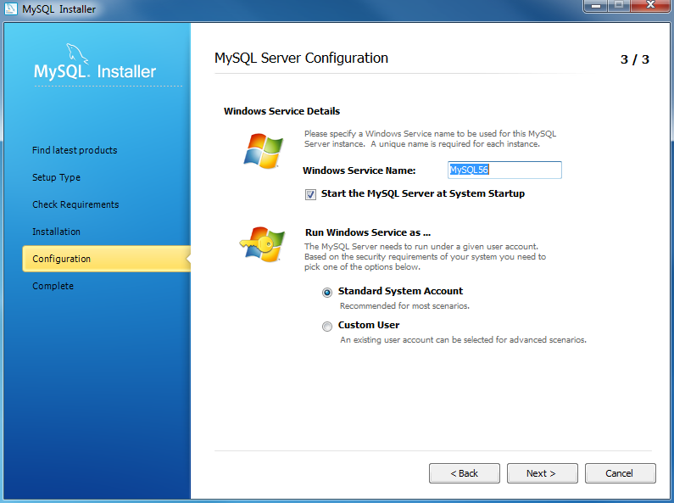  
Install MySQL Step 8.1 – MySQL Server Configuration: choose Windows service details including Windows Service Name and account type, then click Next button to continue.

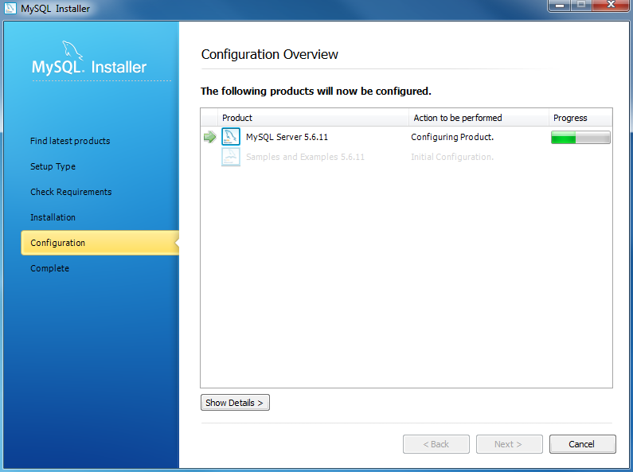  
Install MySQL Step 8.1 – MySQL Server Configuration – In Progress: MySQL Installer is configuring MySQL database server. Wait until it is done and click Next button to continue.

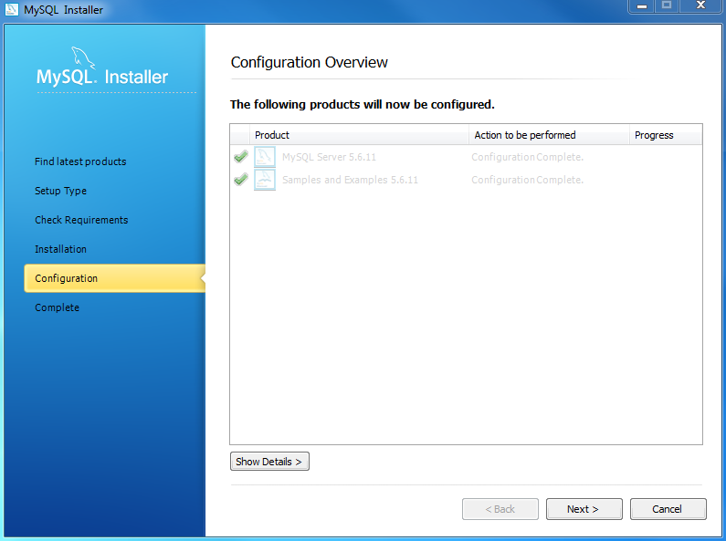  
Install MySQL Step 8.1 – MySQL Server Configuration – Done. Click the Next button to continue.

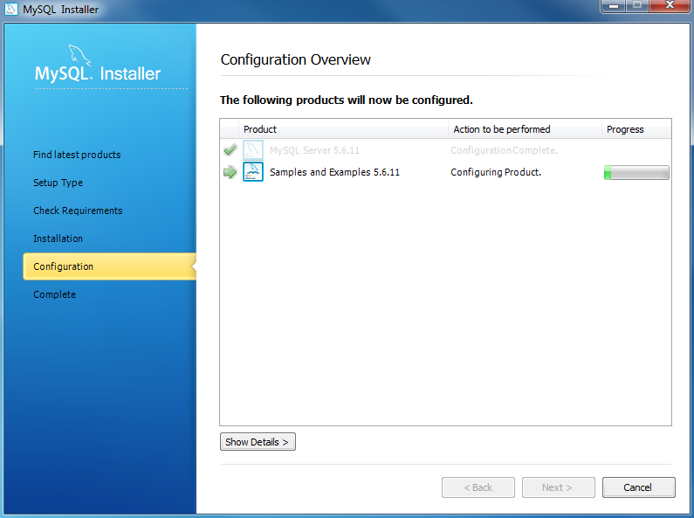  
Install MySQL Step 8.2 – Configuration Overview: MySQL Installer installs sample databases and sample models.

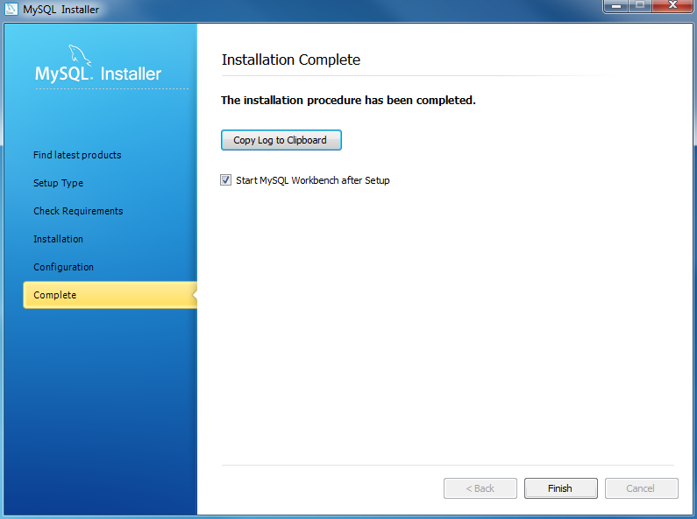

Install MySQL Step 9 – Installation Completes: the installation completes. Click finish button to close the installation wizard and launch the MySQL Workbench.

1. ***Eclipse Installation Guide***
2. Run the Eclipse installer. You should see a window like the one below; Select the first "Eclipse IDE for Java Developers" option.

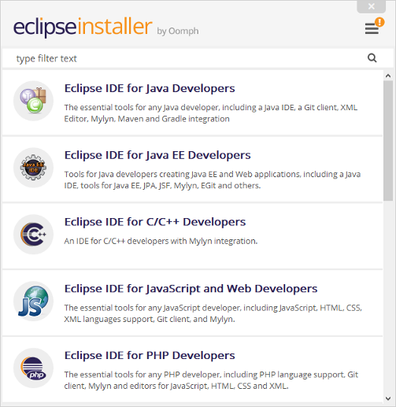

1. After that point, you can keep hitting "yes" and select all the default options (unless you want to change something).

You should eventually see a screen like this. Click the "Launch" button.

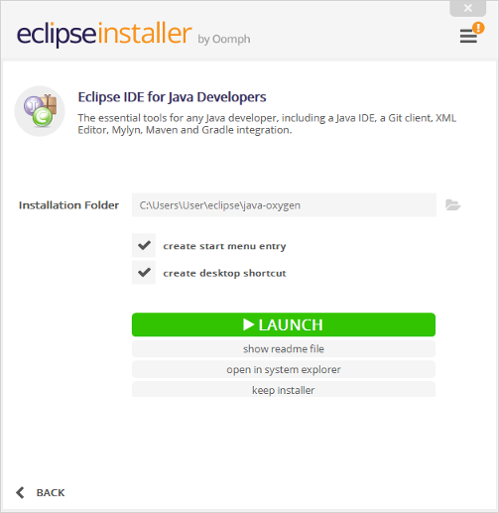

Note that there are some third party libraries that we use, such as JUnit, that are included in the projects and managed with Gradle; see the [project import guide](https://courses.cs.washington.edu/courses/cse373/18au/resources/eclipse-loading-guide.html) for more details.

1. When you run Eclipse, it'll ask you where you want your workspace to be (see screenshot below for example). Your workspace will be the location where Eclipse will add any new projects you create. You can change the location of the workspace if you want: just make sure you remember what you picked.

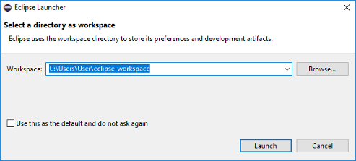

1. Once you're done, you should see a "Welcome" screen like below. Close the "welcome" tab to open the regular editor.

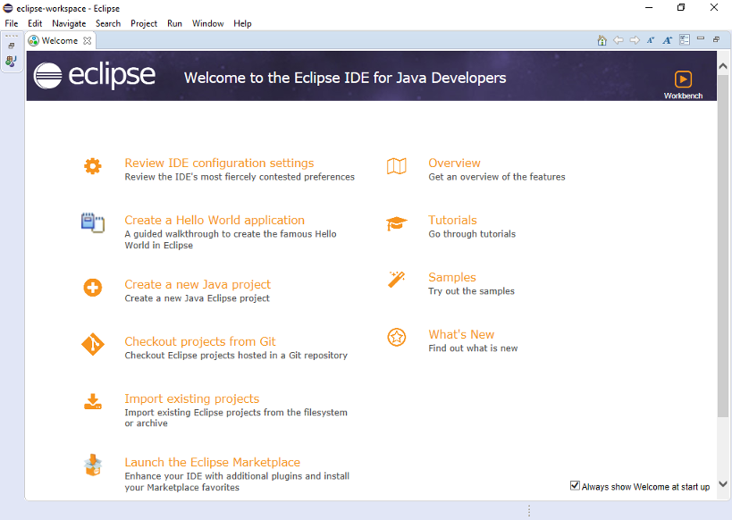

1. Next, select "Windows > Preferences" (PC) or "Eclipse > Preferences" (Mac) in the menu. Then, select "Java > Installed JREs":

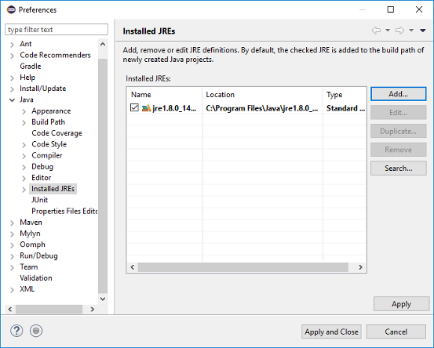

1. Click the "Search" button and select the "Java" folder. This folder should contain your installed JRE and JDK. (If it contains only the installed JDK, that's also ok). You can probably find this folder located at Windows: C:\Program Files\Java

For example:

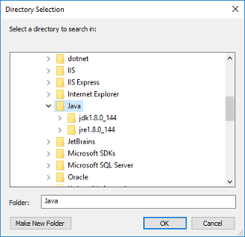

1. After hitting "ok", you should see a screen with a line for either both the JRE and the JDK, or just the JDK. Select the line for the JDK:

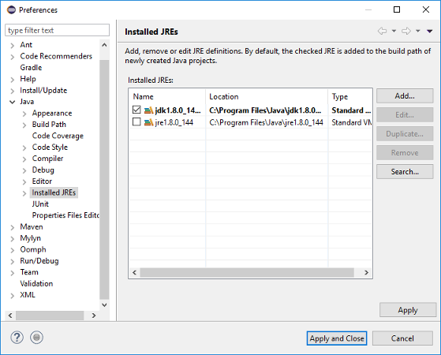

1. Click the "Apply and close" button.
2. Eclipse, by default, contains a fair degree of clutter. If you want to minimize the clutter, feel free to close the "Task List" and "Outline" tabs/views to the right.

After that, open the sql file using mysql and run the code.

And then import the project to eclipse and run.